**LAB#06 EXERCISES**

**INSTRUCTIONS**:

**NOTE: Violation of any of the following instructions may lead to the cancellation of your submission.**

1) Create a folder and name it by your student id (k16-1234).

2) Paste the .c (Save as type) file for each question with the names such as Q1.c, Q2.c and so on into that folder.

**LOOPS OR OTHER HIGHER LEVEL CONCEPTS ARE NOT ALLOWED TO BE USED FOR SOLVING THE FOLLOWING PROBLEMS. USE NESTED IF OR IF-ELSE-IF STRUCTURE TO SOLVE THE PROBLEMS. DON’T USE LOGICAL OPERATORS.** **VIOLATION OF THIS CONDITION WILL RESULT IN ZERO MARKS.**

**QUESTION#1**

Teacher asks the student to check whether the input number is divisible by 7 or not. For checking the divisibility, take the last digit and double it, take the rest of the digits and subtract the doubled last digit repeat until the result is 7, -7 or 0.

For Eg:

10976 -> 1097-12 = 1085 -> 108-10 = 98 -> 9-16 = -7

49 -> 4 - 18 = 14 -> 1 - 8 = -7

**QUESTION#2**

Write a C program to check isosceles, scalene or equilateral triangle when sides are given using conditional operators.

**QUESTION#3**

Write a program that asks for the number of calories and fat grams in a food.  The program should display the percentage of calories that come from fat.  If the calories from fat are less than 30% of the total calories of the food, it should also display a message indicating that the food is low in fat.

One gram of fat has 9 calories, so Calories from fat = fat grams * 9

The percentage of calories from fat can be calculated as: calories from fat/total calories

Input validation: Make sure the number of calories and fat grams are not less than 0.

Also, the number of calories from fat cannot be greater than the total number of calories.  If that happens, display an error message indicating that either the calories or fat grams were incorrectly entered.

**QUESTION#4**

Write a program in which user enters his NTS and F.Sc marks and your program will help student in selection of university. Based on these marks Student will be allocated a seat at different department of different university.

* Oxford University

IT: Above 70% in Fsc. and 70 % in NTS  
Electronics: Above 70% in Fsc. and 60 % in NTS  
Telecommunication Above 70% in Fsc. and 50 % in NTS

* MIT

IT: 70% - 60 % in Fsc. and 50 % in NTS  
Chemical: 59% – 50 % in Fsc. and 50 % in NTS  
Computer: Above 40% and below 50 % in Fsc. and 50 % in NTS

**QUESTION#5**

Write a program that uses a nested for loop to print all prime factors of a number.

**QUESTION#6**

The weekday is true if it is a weekday, and the vacation is true if we are on vacation. We sleep in if it is not a weekday or we're on vacation. Print true if we sleep in.

sleepIn(false, false) → true  
sleepIn(true, false) → false  
sleepIn(false, true) → true

**QUESTION#7**

Write a program to control a coffee machine. Allow the user to input the type of coffee as B for Black and W for White. Ask the user if the cup size is double and if the coffee is manual. The following table details the time chart for the machine for each coffee type. Display a statement for each step. If the coffee size is double, increase the baking time by 50 percent. Use functions to display instructions to the user and to compute the coffee time.

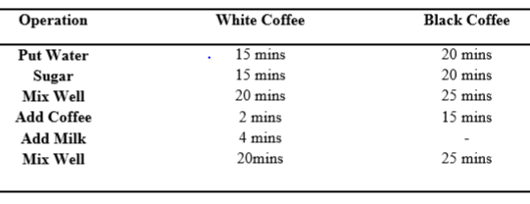

**Note: Use switch structure to solve this problem.**

**QUESTION#8**

The National Earthquake Information Center has asked you to write a program implementing the following decision table to characterize an earthquake based on its Richter scale number.

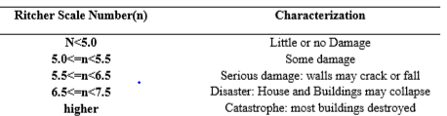

Could you handle this problem with a switch statement? If so, use a switch statement; if not, explain why.

**QUESTION#9**

Using IF and Switch statement, write a program that displays the following menu for the food items available to take order from the customer:

| ∙ | B= Burger | (Rs. 200) |
| --- | --- | --- |
| ∙ | F= French Fries | (Rs. 50) |
| ∙ | P= Pizza | (Rs. 500) |
| ∙ | S= Sandwiches | (Rs. 150) |

The costumer can order any combination of available food. The program first ask to enter the no of types of snacks i.e. 2, 3 or 4 then it ask to enter the choice i.e. B for Burger and then for quantity. The program should finally display the total charges for the order.